Experiment 7: Task Management System with MoSCoW Prioritization in Jira

Course code: CSA1006
Course: Software Engineering
Name: B. Pavani
Register No: 192525248
Tool Used: Jira

Aim
To create a Task Management System project in Jira, add its main features as tasks, prioritize them using the MoSCoW method (Must have, Should have, Could have), and plan them in a sprint.

Software Used
Jira Software (free plan), https://www.atlassian.com/software/jira

Concept of MoSCoW Prioritization
- Must have: Essential features. The system cannot work without them.
- Should have: Important features, but the system can still work for a short time without them.
- Could have: Useful extra features that are added only if time and resources are available.

Procedure

Step 1: Log in to Jira
Open https://www.atlassian.com/software/jira in a browser and log in with your Atlassian account.

Step 2: Create the project
Click "Create" and choose "Space" (project), select the Scrum template and click "Use template". Enter the project name "Exp-7 Task Management System" and the project key "TMS7C", then click "Create".

Step 3: Set the MoSCoW priorities
Open Settings, go to Work items and then Priorities, and set the priority names Must have, Should have and Could have so that they can be selected on each task.

Step 4: Add the tasks to the backlog
Open the "Backlog" tab, click "+ Create" and type each task name, then press Enter. Add the four main features of the task management system listed in the table below. Jira numbers them TMS7C-1 to TMS7C-4.

Issue | Task Name | Priority | Status
TMS7C-1 | User Login and Role Assignment | Must have | To Do
TMS7C-2 | Task Creation and Assignment | Must have | To Do
TMS7C-3 | Task Prioritization and Deadlines | Should have | To Do
TMS7C-4 | Progress Tracking and Reporting | Could have | To Do

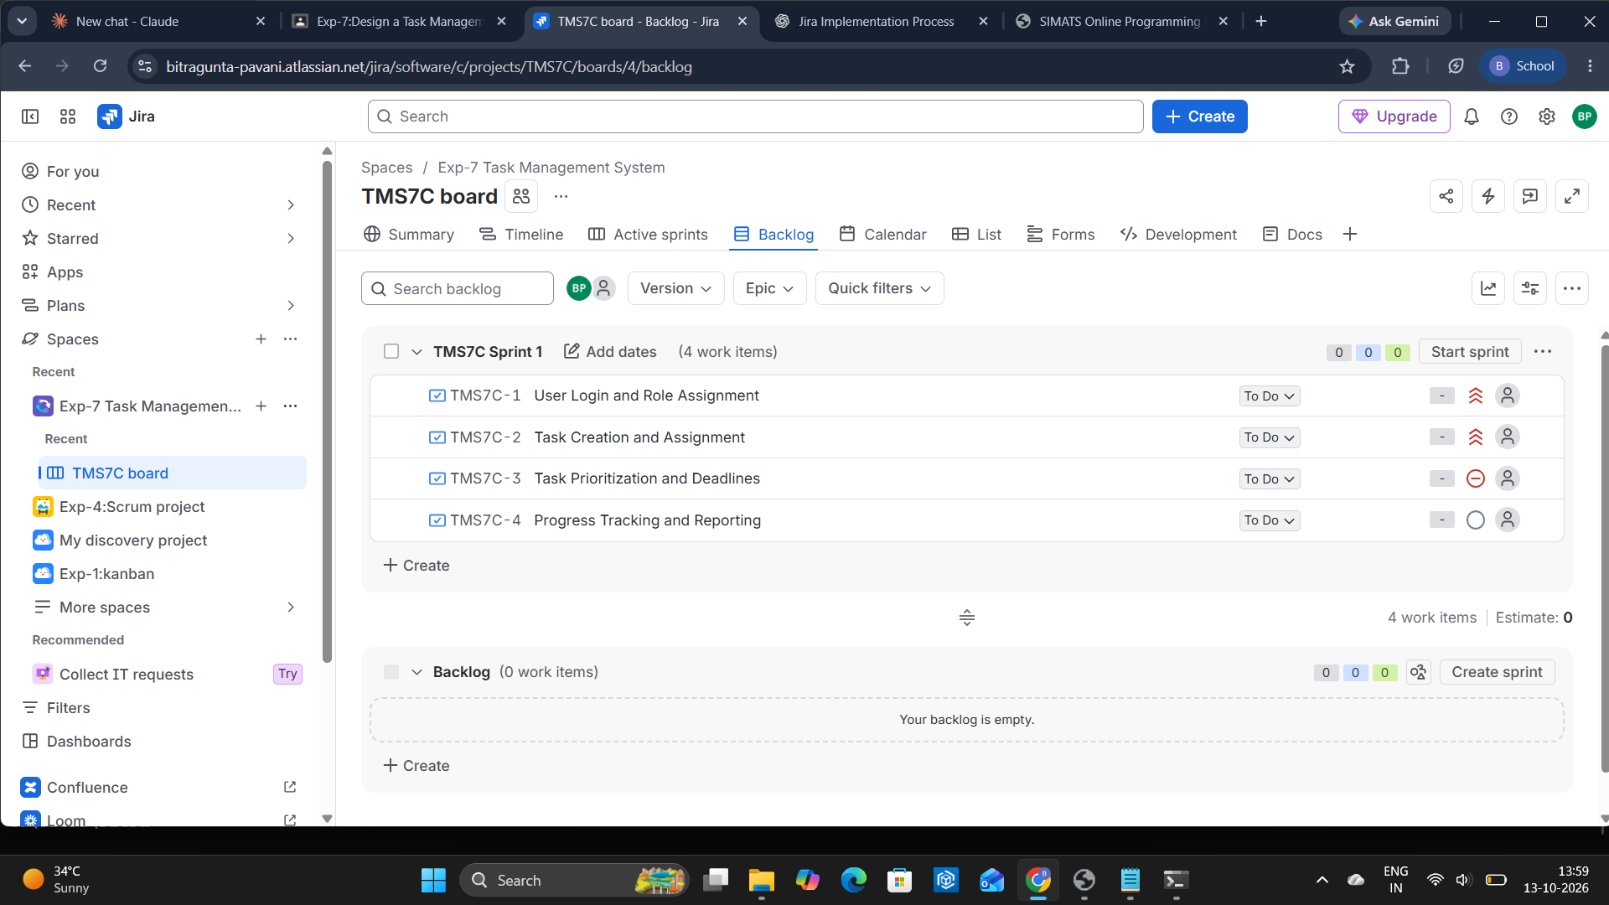
Figure 2: Backlog view with the four tasks in TMS7C Sprint 1

Step 5: Assign the priority to each task
Open the "List" tab and click the Priority column of each task to select its MoSCoW priority. TMS7C-1 and TMS7C-2 are Must have, TMS7C-3 is Should have and TMS7C-4 is Could have.

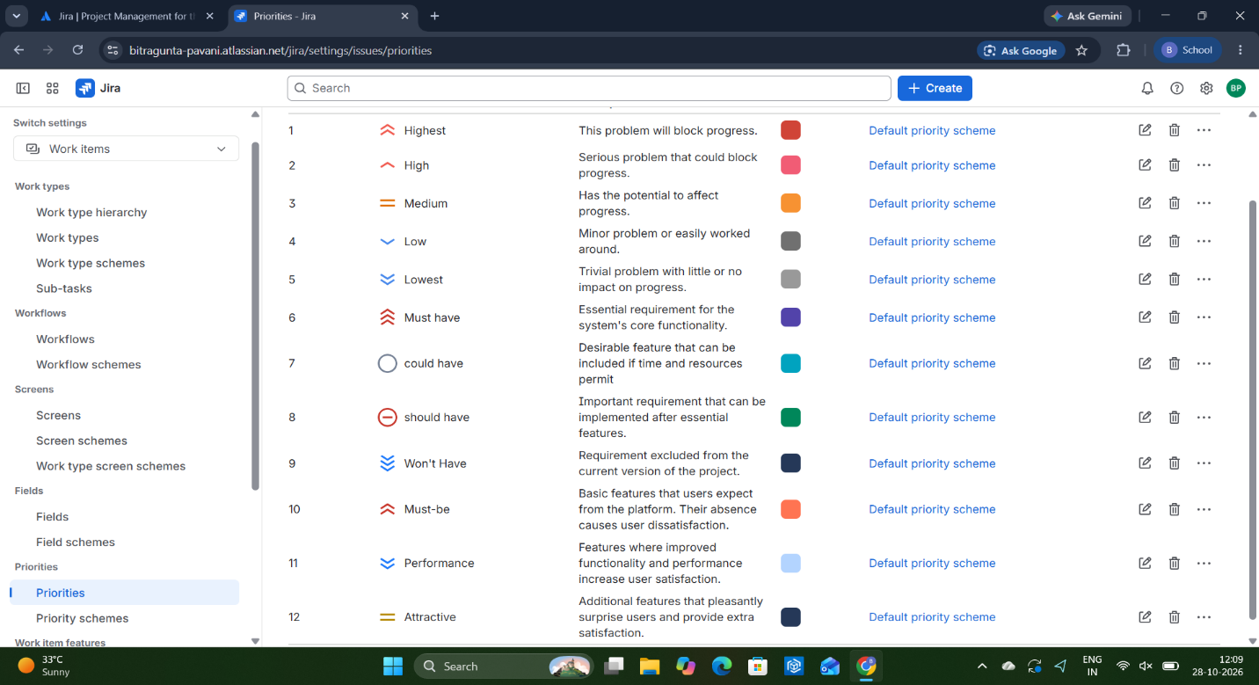
Figure 1: List view of the tasks with their MoSCoW priorities

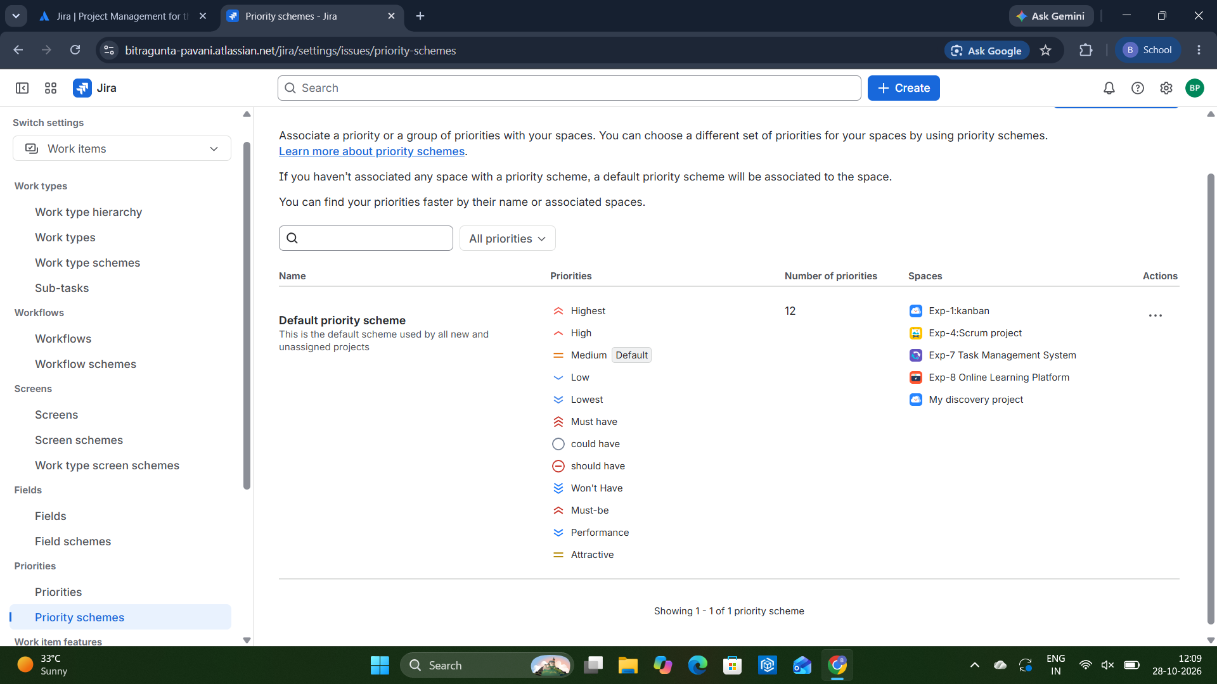

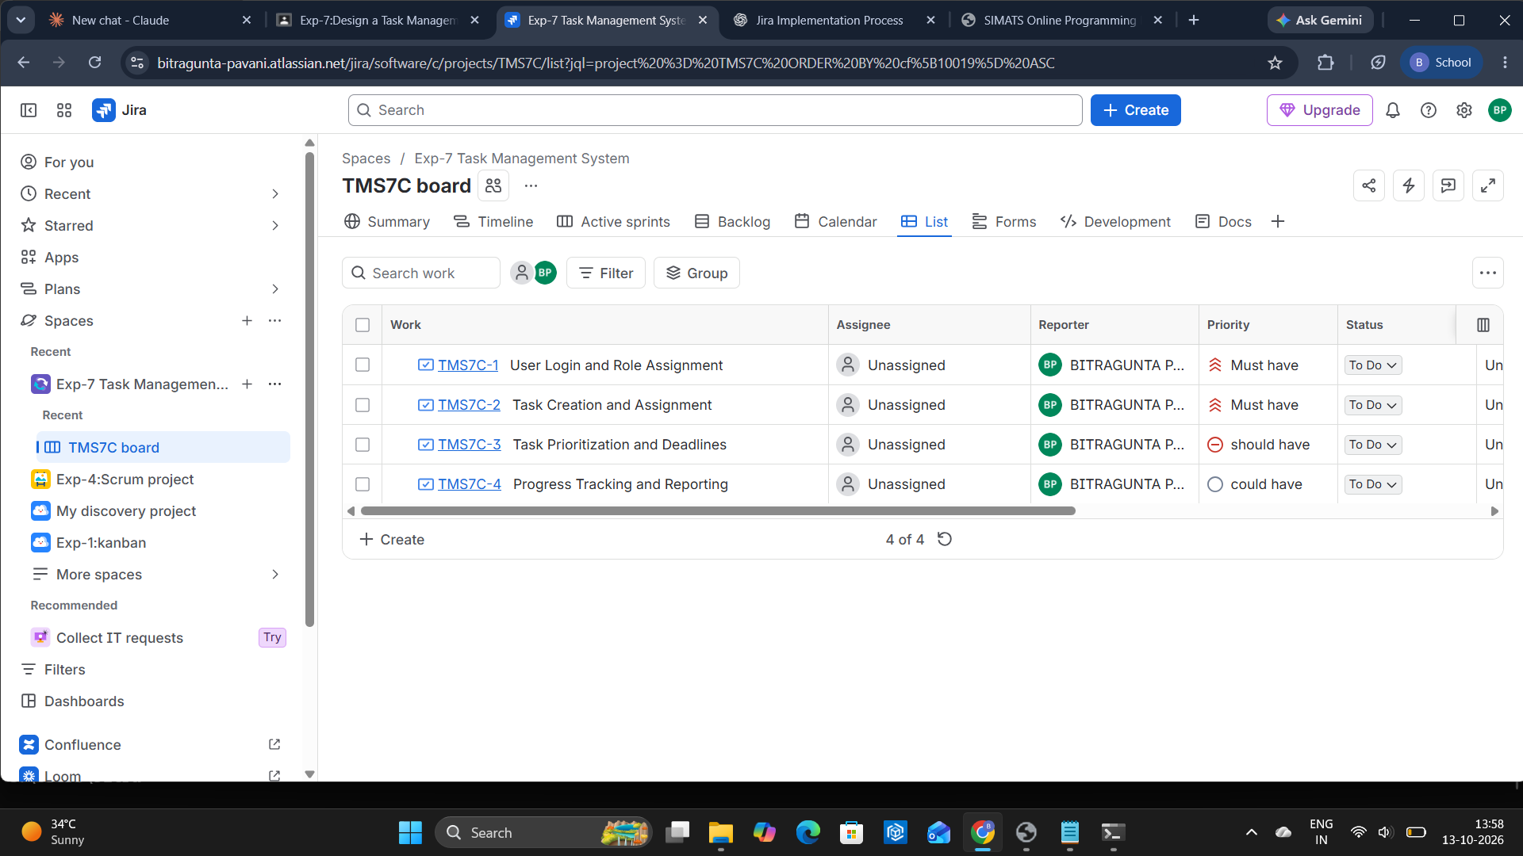

Step 6: Plan the sprint
Open the "Backlog" tab. The four tasks are added to "TMS7C Sprint 1". The sprint is ready, and clicking "Start sprint" will begin the work on these tasks

Reason for the Priorities
Task | Priority | Reason
User Login and Role Assignment | Must have | Users must log in securely and have the right role before using the system.
Task Creation and Assignment | Must have | Creating and assigning tasks is the main purpose of the system.
Task Prioritization and Deadlines | Should have | Important for planning, but tasks can be managed for a while without it.
Progress Tracking and Reporting | Could have | Useful for monitoring, but it can be added after the core features.

Priority Summary
Priority | Tasks | Number of tasks
Must have | TMS7C-1, TMS7C-2 | 2
Should have | TMS7C-3 | 1
Could have | TMS7C-4 | 1
Total |  | 4

Result
A Task Management System project was created in Jira. Four main features were added as tasks and prioritized using the MoSCoW method: two Must have, one Should have and one Could have. The tasks were planned in TMS7C Sprint 1, which is ready to be started.

